**Reasons for rejection of delay compensation**

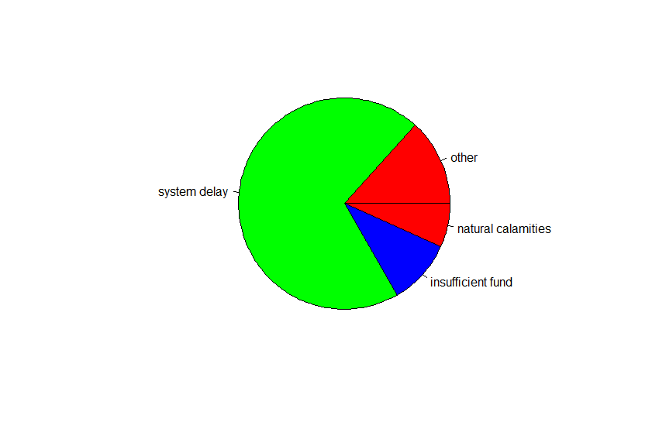

frequency of reason of rejection

The next data set that we are mining is to find out the reasons for rejection of delay compensation. The first figure is a pie chart showing the frequency of each reason. The reasons include natural calamities, insufficient fund and system delay. When natural calamities occur the government cannot be held responsible for delay of wage payment so the compensation is rejected. When there is a breakdown in server or the database(System delay) the delay caused in payment may be exempted causing the rejection of compensation. When there is no sufficient fund to pay the wages the delay is not compensated.

Evidently the major reason for rejection of delay compensation is system delay

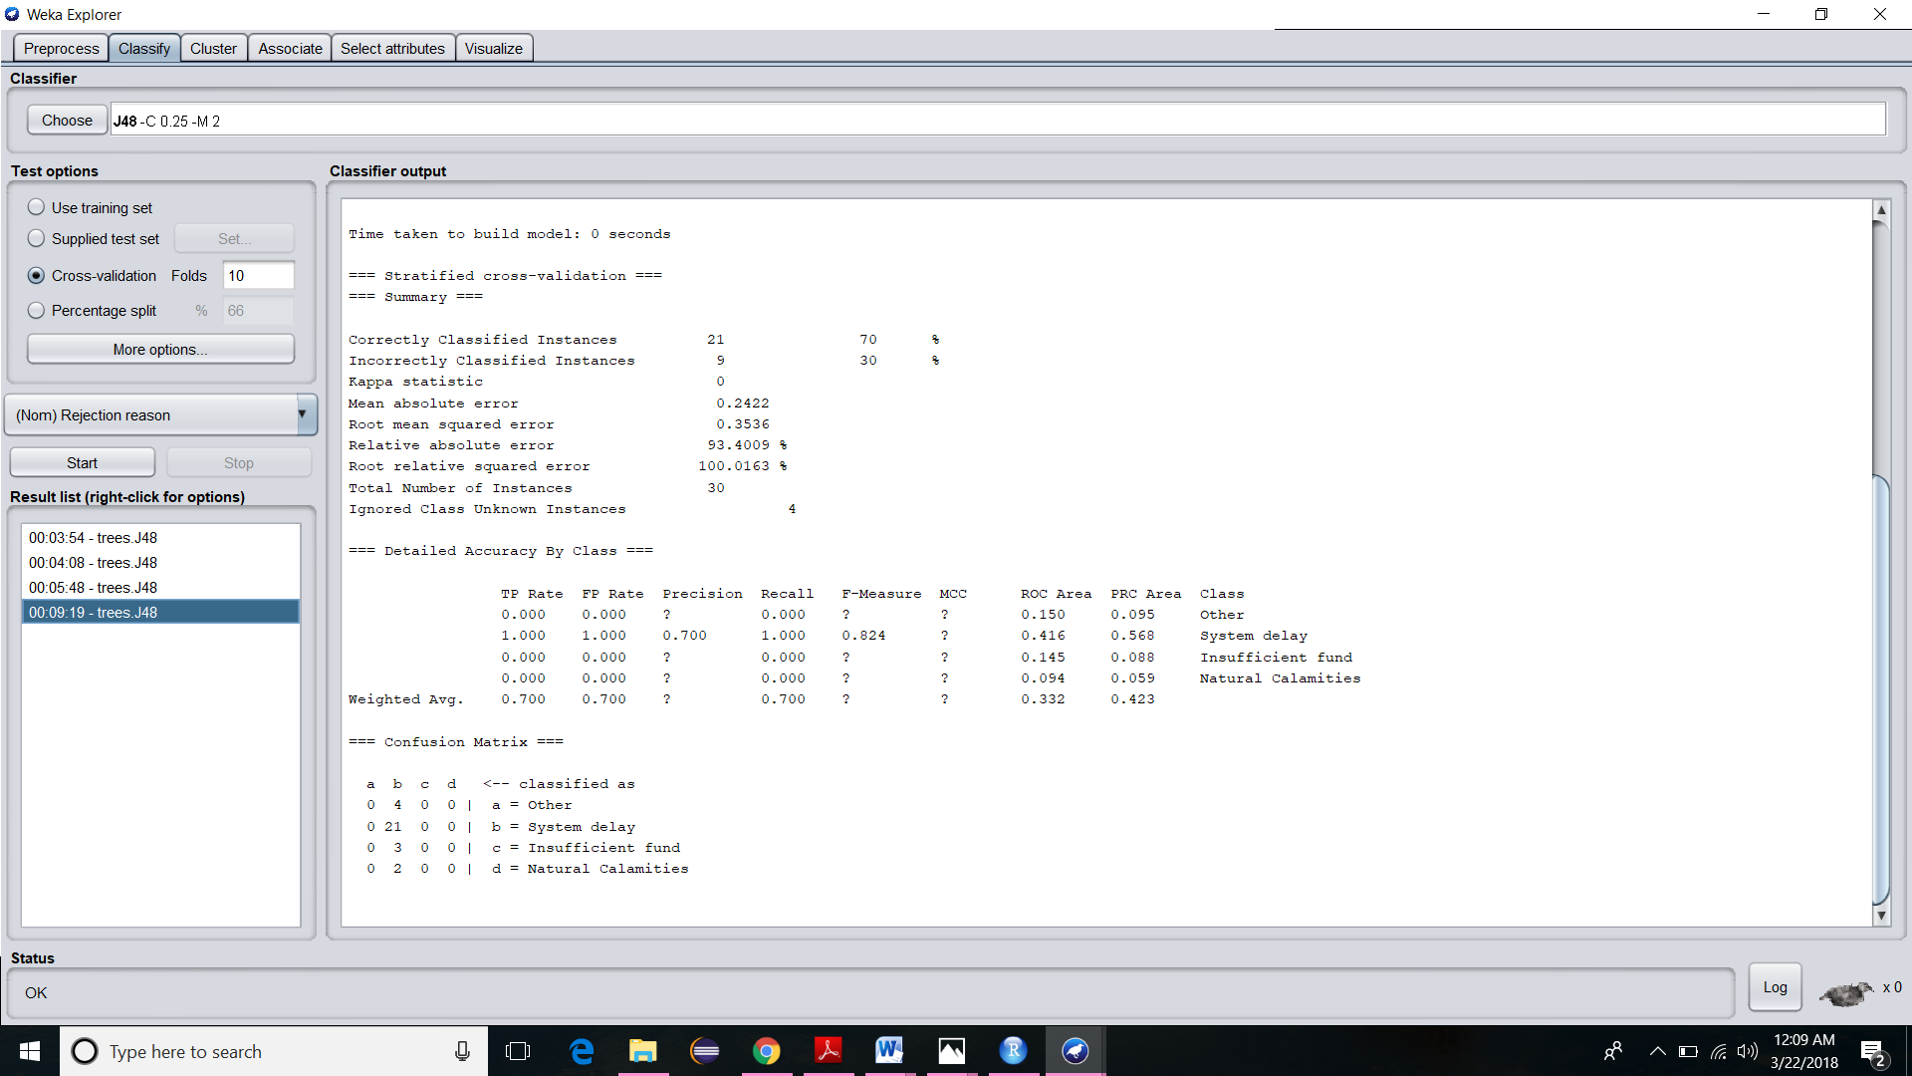

Confusion matrix for the classification

The data set on classification using J48 algorithm produces the above confusion matrix. As it clearly understood, System delay, Insufficient fund, Natural calamities and Others are the class labels and the states are classified under the respective class labels having frequency 21,3,2and 4.

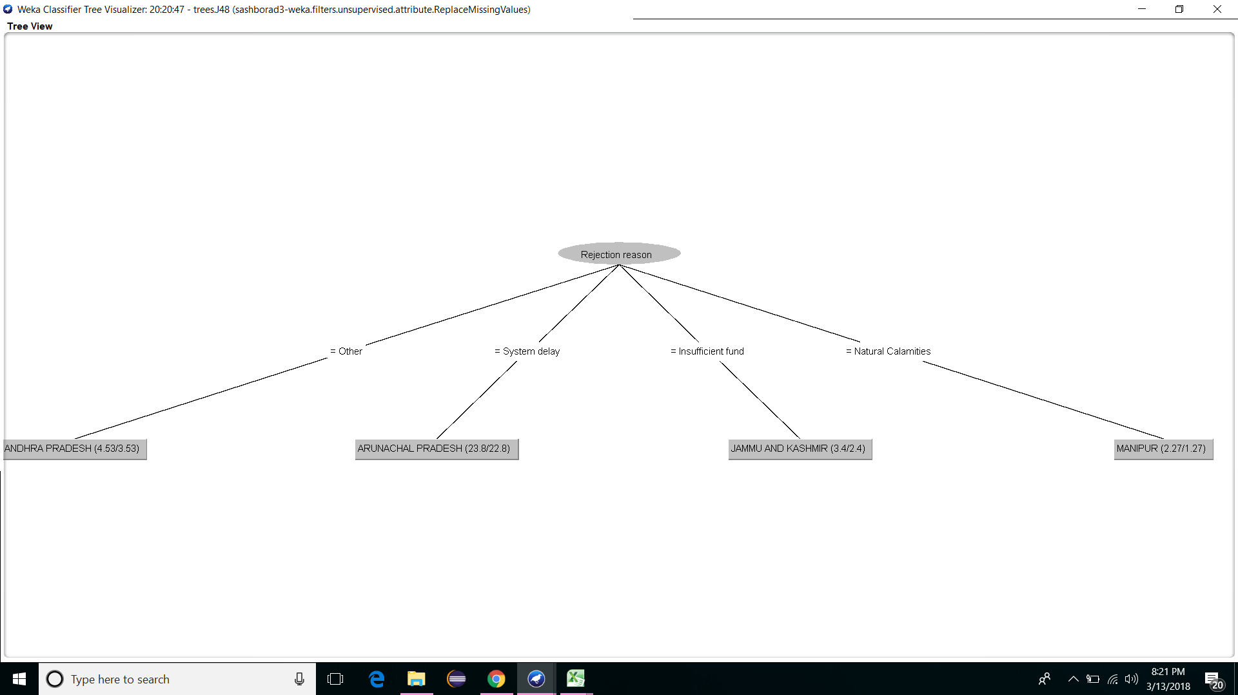

clasification tree of rejection reason

The classification tree generated while classifying the states with respect to the various reasons for rejection of delay compensation is shown above.